TASK – 1

Question 1: Shape Hierarchy with Virtual draw()

Create a base class Shape with a pure virtual function draw() that has no implementation.

Derive classes like Circle, Square, and Triangle from Shape, each overriding draw() to provide their specific drawing behavior (e.g., using cout for simple output or more advanced graphics libraries).

Write a main function that creates an array of pointers to Shape objects. Populate the array with instances of derived classes (polymorphism).

Iterate through the array and call draw() on each pointer using a loop. Observe how the correct draw() implementation is invoked based on the object's type at runtime.

A: #include <iostream>

using namespace std;

class shape {

public:

virtual void draw() const = 0; // Pure virtual function

virtual ~shape() {}

};

class Circle : public shape {

public:

void draw() const override {

cout << "Drawing Circle" << endl;

} };

class Square : public shape {

public:

void draw() const override {

cout << "Drawing Square" << endl;

} };

class Triangle : public shape {

public:

void draw() const override {

cout << "Drawing Triangle" << endl;

} };

int main() {

shape* Shapes[3]; // Create an array of pointers to Shape objects

Shapes[0] = new Circle(); // Array with instances of derived classes

Shapes[1] = new Square();

Shapes[2] = new Triangle();

for (int i = 0; i < 3; ++i) { // Iterate through the array and call draw() on each pointer

Shapes[i]->draw();

}

return 0;

}

OUTPUT:  
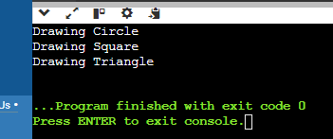

Question 2: Abstract Animal Class with Virtual makeSound()

Design an abstract base class Animal with a pure virtual function makeSound() that each derived class must implement differently (e.g., cout for "Meow", "Woof", etc.).

Create concrete classes Cat, Dog, and potentially others, inheriting from Animal and overriding makeSound().

In main, create a function playAnimalSound that takes an Animal reference as an argument. Inside, call makeSound() on the reference. Demonstrate runtime polymorphism by passing objects of different derived classes to playAnimalSound and observing the correct sound being played.

A: #include <iostream>

using namespace std;

class Animal {

public:

virtual void makeSound() const = 0; // Pure virtual function

virtual ~Animal() {}

};

class Cat : public Animal {

public:

void makeSound() const override {

cout << "Meow.." << endl;

}

};

class Dog : public Animal {

public:

void makeSound() const override {

cout << "Bark.." << endl;

}

};

void playAnimalSound(const Animal& animal) {

animal.makeSound();

} int main() {

Cat cat;

Dog dog;

playAnimalSound(cat);

playAnimalSound(dog);

return 0;

}

OUTPUT:  
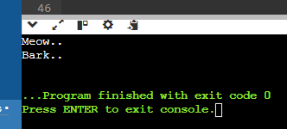

Question 3: Area Calculation with Virtual Destructors

Define a base class Shape with a member function area() that returns 0 (since it's a base class). Make Shape abstract using a pure virtual destructor.

Derive classes Circle, Square, and Triangle, each overriding area() with their specific area calculation formulas.

In main, create an array of pointers to Shape objects. Allocate memory dynamically for each object using new from the derived classes.

Iterate through the array and call area() on each pointer. Notice how the appropriate area() implementation is chosen based on the object's type at runtime, even though the array holds Shape pointers.

Crucially, remember to delete each object using delete to avoid memory leaks. This demonstrates the importance of virtual destructors in polymorphism scenarios with dynamic memory allocation.

A: #include <iostream>

#include <cmath>

using namespace std;

class Shape {

public:

virtual int area() const {

return 0; }

virtual ~Shape() = 0; // Pure virtual destructor

};

Shape::~Shape() {}

class Circle : public Shape {

private:

int radius;

public:

Circle(int r) : radius(r) {}

int area() const override {

return M_PI * radius * radius; }

};

class Square : public Shape {

private:

int side;

public:

Square(int s) : side(s) {}

int area() const override {

return side * side; }

};

class Triangle : public Shape {

private:

int base, height;

public:

Triangle(int b, int h) : base(b), height(h) {}

int area() const override {

return 0.5 * base * height; }

};

int main() { // Create an array

Shape* shapes[] = {new Circle(10), new Square(9), new Triangle(3, 6)};

for (Shape* shape : shapes) { // Iterate through the array and call area() on each pointer

cout << "Area: " << shape->area() << endl;

}

return 0;

}

OUTPUT:  
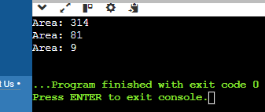

Question 4: Virtual Destructor and Slicing

Create a base class Shape with a member variable color and a virtual destructor.

Derive a class Circle from Shape that adds a member variable radius.

In main, create a Circle object on the stack and assign it to a Shape reference. Then, delete the reference.

Explain why this leads to object slicing (the radius member is not deleted) and the importance of virtual destructors in preventing it. Discuss how virtual destructors ensure the complete destruction of derived class objects when accessed through base class pointers or references.

A: # include <iostream>

using namespace std;

class Shape {

protected:

string color;

public:

Shape(const string& c) : color(c) {}

virtual ~Shape() {

cout << "Shape destructor called" << endl;

}

};

class Circle : public Shape {

private:

double radius;

public:

Circle(const string& c, double r) : Shape(c), radius(r) {}

~Circle() override {

cout << "Circle destructor called" << endl;

}

};

int main() {

Circle circle("red", 5.0);

Shape& shapeRef = circle;

Shape* shapePtr = new Circle("blue", 10.0);

delete shapePtr; // Correctly calls the Circle destructor due to the virtual destructor in Shape

return 0;

}

OUTPUT:  
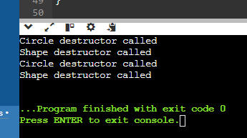

Question 5: Runtime Type Information (RTTI)

Create base and derived classes with virtual functions.

In main, use the typeid operator to obtain runtime type information of objects.

Write a function identifyObject that takes a reference to an object and uses typeid to check if it's of a specific derived class type. Based on the type, perform different actions or print messages.

Discuss the pros and cons of using RTTI. While it can provide flexibility in certain cases, overuse can sometimes make code less type-safe and harder to maintain. Consider alternative design patterns when possible.

tune

share

more_vert

expand_content

add_photo_alternatephoto_camera

A: #include <iostream>

#include <typeinfo>

using namespace std;

class Shape {

public:

virtual void draw() const {

cout << "Drawing Shape" << endl; }

virtual ~Shape() {}

};

class Circle : public Shape {

public:

void draw() const override {

cout << "Drawing Circle" << endl; }

};

class Square : public Shape {

public:

void draw() const override {

cout << "Drawing Square" << endl; }

};

void identifyObject(const Shape& shape) {

if (typeid(shape) == typeid(Circle)) {

cout << "This is a Circle." << endl;

} else if (typeid(shape) == typeid(Square)) {

cout << "This is a Square." << endl;

} else {

cout << "This is an unknown Shape." << endl;

}

shape.draw();

}

int main() {

Circle circle;

Square square;

Shape* shapes[] = { &circle, &square };

for (Shape* shape : shapes) {

identifyObject(*shape); }

return 0;

}

OUTPUT:

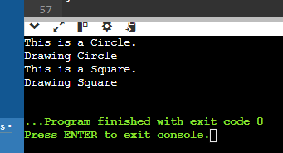

5. RTTI (Run-Time Type Information) is like a detective tool in programming. It lets you figure out the exact type of an object at runtime, even if you don't know it beforehand. This can be really handy for things like:

*Pros:*

* *Flexibility:* You can write code that works with different types of objects without knowing their exact types in advance. This is great for things like polymorphism, where you want to handle different objects in a similar way.

* *Dynamic Behavior:* You can change the behavior of your code based on the type of object you're working with. This is useful for things like plugins or customizability.

*Cons:*

* *Less Type-Safe:* Since you're not always sure what type of object you're dealing with, there's a higher chance of errors. You might try to use a method that doesn't exist on that particular type, leading to crashes.

* *Harder to Maintain:* Code that uses RTTI can be harder to understand and maintain because it's not always clear what types of objects are being used. This can make it difficult to track down bugs and make changes.

* *Templates:* Templates allow you to write code that works with different types without needing to know the exact type at compile time. This can be a good alternative to RTTI for situations where you need to work with different types but don't need to know the exact type at runtime.

*In short:* RTTI can be useful in certain situations, but it's important to use it sparingly. If you can achieve the same functionality with other techniques, it's often a better idea to do so.

-------------------------------------------------------------------------------------------------------------------------------

TASK – 2

1. Polymorphism:

Design a class hierarchy for a simple graphic editor with base class Shape and derived classes Circle, Rectangle, and Triangle. Implement a virtual function draw() in the base class and override it in the derived classes. Write a function that takes a Shape* and calls its draw() method.

#include <iostream>

using namespace std;

class Shape {

public:

virtual void draw() const {

cout << "Drawing a shape" << endl; }

};

class Circle : public Shape {

public:

void draw() const override {

cout << "Drawing a circle" << endl; }

};

class Rectangle : public Shape {

public:

void draw() const override {

cout << "Drawing a rectangle" << endl; }

};

class Triangle : public Shape {

public:

void draw() const override {

cout << "Drawing a triangle" << endl; }

};

void drawShape(const Shape* shape) {

shape->draw();

}

int main() {

Circle circle;

Rectangle rectangle;

Triangle triangle;

drawShape(&circle);

drawShape(&rectangle);

drawShape(&triangle);

return 0;

}

OUTPUT:



1. Static Members:

Create a class Account that has a static data member totalAccounts to keep track of the number of accounts created. Implement necessary constructors and destructors to update totalAccounts. Write a function to display the total number of accounts.

A: #include <iostream>

using namespace std;

class Account {

private:

static int totalAccounts; // Static data member to keep track of total accounts

public:

Account() {

totalAccounts++; }

static int getTotalAccounts() {

return totalAccounts; }

};

int Account::totalAccounts = 0;

void displayTotalAccounts() {

cout << "Total Accounts: " << Account::getTotalAccounts() << endl; }

int main() {

Account acc1;

Account acc2;

Account acc3;

displayTotalAccounts(); {

Account acc4;

displayTotalAccounts(); }

displayTotalAccounts(); // Output: Total Accounts: 3

return 0;

}

OUTPUT:

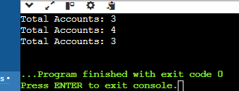

1. Friend Functions:

Implement a class Box that has private data members length, breadth, and height. Write a friend function volume() that calculates and returns the volume of the box. Create objects of Box and use the friend function to compute their volumes.

A: #include <iostream>

using namespace std;

class Box;

int volume(const Box& box);

class Box {

private:

int length;

int breadth;

int height;

public:

Box(int l, int b, int h) : length(l), breadth(b), height(h) {}

friend int volume(const Box& box);

};

int volume(const Box& box) {

return box.length * box.breadth * box.height; }

int main() {

Box box1(3, 4, 5);

Box box2(2, 2, 2);

int vol1 = volume(box1);

int vol2 = volume(box2);

cout << "Volume of Box 1: " << vol1 << " units" << endl;

cout << "Volume of Box 2: " << vol2 << " units" << endl;

return 0;

}

OUTPUT:

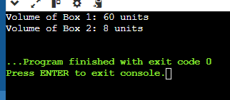

1. Templates:

Write a template class Array that can store an array of any data type. Include member functions to perform operations like adding an element, removing an element, and displaying the array. Demonstrate the functionality with different data types.

A: #include <iostream>

#include <cassert>

using namespace std;

template <typename T>

class Array {

private:

T* elements; // Pointer to dynamically allocated array

int capacity; // Capacity of the array (maximum elements it can hold)

int size; // Current number of elements in the array

public:

Array(int initialCapacity) : capacity(initialCapacity), size(0) {

elements = new T[capacity];

}

void add(const T& element) { // Function to add an element to the array

assert(size < capacity);

elements[size++] = element; }

void remove() {

if (size > 0) {

--size; }

}

void display() const {

cout << "Array elements:";

for (int i = 0; i < size; ++i) {

cout << " " << elements[i]; }

cout << endl; }

};

int main() {

Array<int> intArray(5);

intArray.add(10);

intArray.add(20);

intArray.add(30);

intArray.display();

Array<string> stringArray(3);

stringArray.add("Hello");

stringArray.add("World");

stringArray.display();

return 0;

}

OUTPUT:

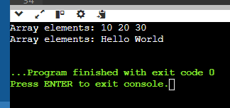

1. Pointers:

Design a class Student with data members name and age. Create an array of Student objects dynamically using pointers. Implement functions to set and display the details of students. Also, write a function to deallocate the memory.

A: #include <iostream>

#include <string>

using namespace std;

class Student {

private:

string name;

int age;

public:

Student() : name(""), age(0) {}

Student(const string& n, int a) : name(n), age(a) {}

void setDetails(const string& n, int a) {

name = n;

age = a; }

void display() const {

cout << "Name: " << name << ", Age: " << age << endl; }

int main() {

int numStudents;

cout << "Enter the number of students: ";

cin >> numStudents;

Student* students = new Student[numStudents];

for (int i = 0; i < numStudents; ++i) {

string name;

int age;

cout << "\nEnter details for student " << i + 1 << ":" << endl;

cout << "Name: ";

cin.ignore(); // Ignore newline left in the buffer

getline(cin, name);

cout << "Age: ";

cin >> age;

students[i].setDetails(name, age); }

cout << "\nDisplaying details of students:" << endl;

for (int i = 0; i < numStudents; ++i) {

students[i].display(); }

delete[] students;

return 0;

}

OUTPUT:

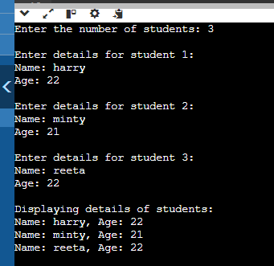

1. Polymorphism with Abstract Classes:

Create an abstract class Animal with a pure virtual function sound(). Derive classes Dog, Cat, and Cow from Animal and override the sound() function in each derived class. Write a program to demonstrate polymorphism using these classes.

A: #include <iostream>

using namespace std;

class Animal { // Abstract class Animal

public:

virtual void sound() const = 0; // Pure virtual function

virtual ~Animal() {} // Virtual destructor

};

class Dog : public Animal {

public:

void sound() const override {

cout << "Dog: Woof!" << endl; }

};

class Cat : public Animal {

public:

void sound() const override {

cout << "Cat: Meow!" << endl; }

};

class Cow : public Animal {

public:

void sound() const override {

cout << "Cow: Moo!" << endl; }

};

int main() {

const int numAnimals = 3;

Animal* animals[numAnimals];

animals[0] = new Dog();

animals[1] = new Cat();

animals[2] = new Cow();

for (int i = 0; i < numAnimals; ++i) {

animals[i]->sound(); } // Polymorphic behavior

return 0;

}

OUTPUT:  
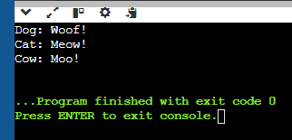

1. Static Member Functions:

Implement a class Math that has static member functions for basic mathematical operations like addition, subtraction, multiplication, and division. Demonstrate the use of these functions without creating an object of the class.

A: #include <iostream>

using namespace std;

class Math {

public:

static int addition(int a, int b) {

return a + b; }

static int subtraction(int a, int b) {

return a - b; }

static int multiplication(int a, int b) {

return a * b; }

static double division(int a, int b) {

if (b == 0) {

cerr << "Error: Division by zero!" << endl;

return 0.0; // Error case }

return static_cast<double>(a) / b; }

};

int main() {

int x = 9, y = 5; // Using static member functions without creating an object

cout << "Addition: " << Math::addition(x, y) << endl;

cout << "Subtraction: " << Math::subtraction(x, y) << endl;

cout << "Multiplication: " << Math::multiplication(x, y) << endl;

cout << "Division: " << Math::division(x, y) << endl;

return 0;

}

OUTPUT:

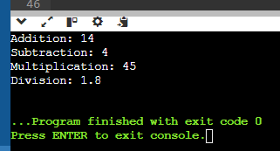

1. Friend Classes:

Create two classes Alpha and Beta. Make Beta a friend class of Alpha so that it can access private data members of Alpha. Implement functions in Beta to manipulate the private data of Alpha.

A: #include <iostream>

using namespace std;

class Beta; // Forward declaration of Beta

class Alpha {

private:

int data;

public:

Alpha(int value) : data(value) {}

void display() const {

cout << "Alpha data: " << data << endl; }

friend class Beta; // Make Beta a friend class of Alpha

};

class Beta {

public:

void setData(Alpha& a, int value) {

a.data = value; }

void addData(Alpha& a, int value) {

a.data += value; }

};

int main() {

Alpha a(10);

a.display();

Beta b;

b.setData(a, 20);

cout << "After setting data to 20:" << endl;

a.display();

b.addData(a, 5);

cout << "After adding 5 to data:" << endl;

a.display();

return 0;

}

OUTPUT:

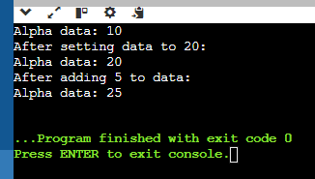

1. Class Templates with Multiple Parameters:

Write a class template Pair that can store a pair of values of any two data types. Include member functions to set and get the values. Demonstrate the usage of this template with different data types.

A: #include <iostream>

#include <string>

using namespace std;

template <typename T1, typename T2>

class Pair {

private:

T1 first;

T2 second;

public:

void setValues(const T1& f, const T2& s) {

first = f;

second = s; }

T1 getFirst() const {

return first; }

T2 getSecond() const {

return second; }

void display() const {

cout << "First: " << first << ", Second: " << second << endl; }

};

int main() {

Pair<int, double> p1; // Pair of int and double

p1.setValues(42, 3.14);

cout << "Pair1: " << endl;

p1.display();

Pair<string, int> p2; // Pair of string and int

p2.setValues("Age", 25);

cout << "\nPair2:" << endl;

p2.display();

return 0;

}

OUTPUT:

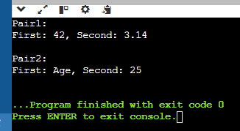

1. Pointer to Objects:

Define a class Book with data members title and author. Create an array of pointers to Book objects. Write functions to input details for each book, display the details, and search for a book by title.

A: #include <iostream>

#include <string>

using namespace std;

class Book {

private:

string title;

string author;

public:

void setDetails(const string& t, const string& a) {

title = t;

author = a; }

string getTitle() const {

return title; }

void display() const {

cout << "Title: " << title << ", Author: " << author << endl; }

};

void inputDetails(Book* books[], int n) { // Function to input details for each book

string title, author;

for (int i = 0; i < n; ++i) {

cout << "Enter details for book " << i + 1 << endl;

cout << "Title: ";

getline(cin, title);

cout << "Author: ";

getline(cin, author);

books[i] = new Book();

books[i]->setDetails(title, author);

}

} void displayDetails(Book* books[], int n) { // Function to display details of all books

for (int i = 0; i < n; ++i) {

books[i]->display();

}

}

Book* searchByTitle(Book* books[], int n, const string& title) {

for (int i = 0; i < n; ++i) {

if (books[i]->getTitle() == title) {

return books[i];

} }

return nullptr;

}

int main() {

int n;

cout << "Enter the number of books: ";

cin >> n;

cin.ignore();

Book* books[n];

inputDetails(books, n);

cout << "\nDisplaying book details:\n";

displayDetails(books, n);

string title;

cout << "\nEnter the title of the book to search: ";

getline(cin, title);

Book* foundBook = searchByTitle(books, n, title);

if (foundBook) {

cout << "\nBook found:\n";

foundBook->display();

} else {

cout << "\nBook not found.\n";

}

return 0; }

OUTPUT:  
